Contents

Tramore AC Application Home Page 1

User Logged In Home Page 1

User Profile Page 2

Edit Profile Details 2

Member Delete 3

Fixtures Page 5

Blog View 5

Add Blog Post 6

Post Comment 7

Kit Catalogue View 8

Kit Catalogue Filtered Views 9

Kit List Catalogue Item View 10

# Tramore AC Application Home Page

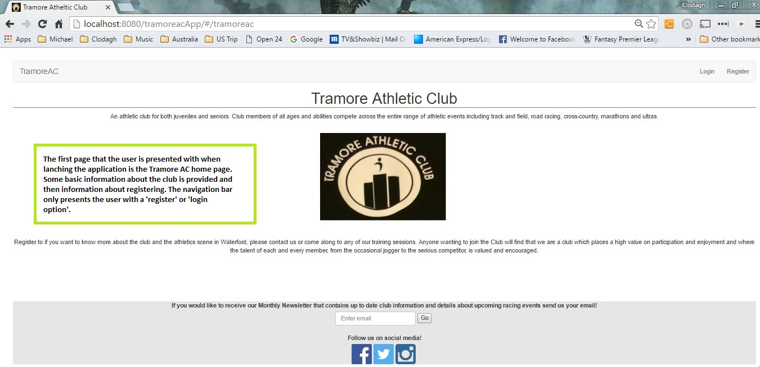

# User Logged In Home Page

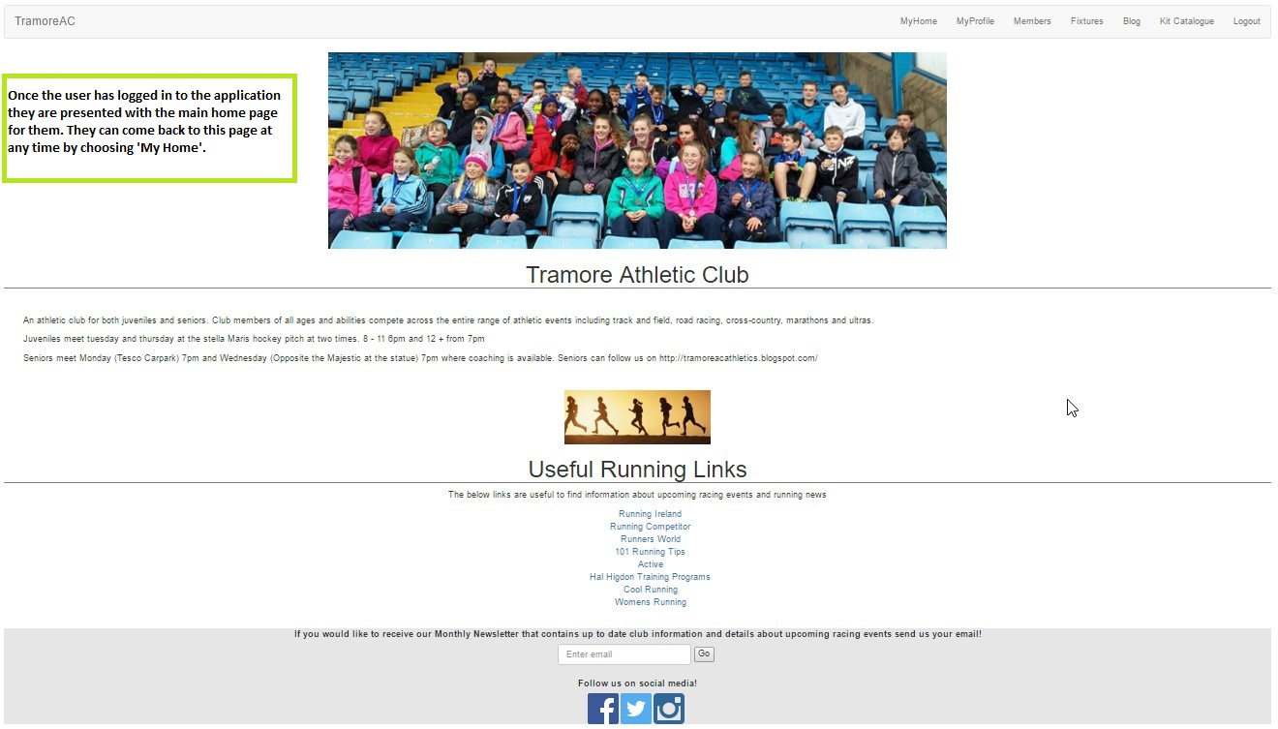

# User Profile Page

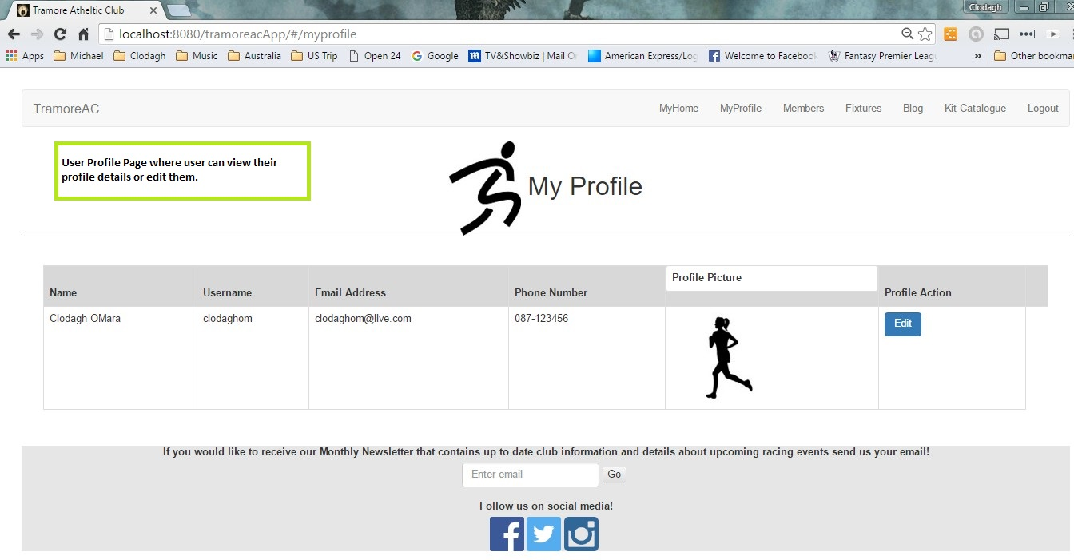

## Edit Profile Details

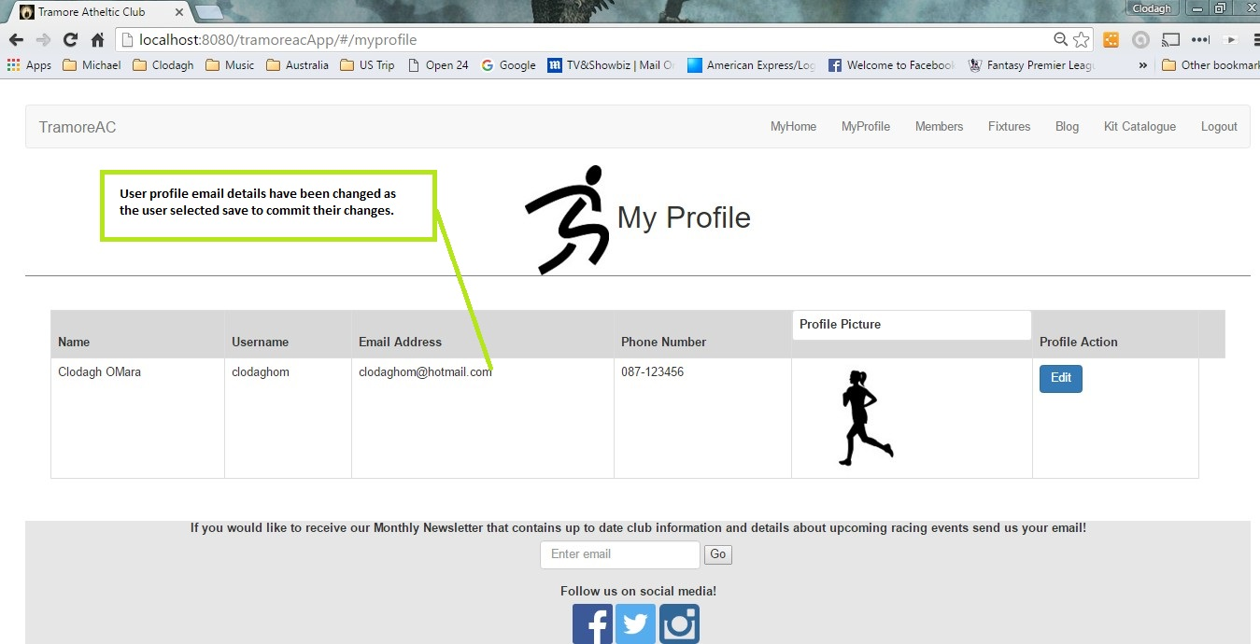

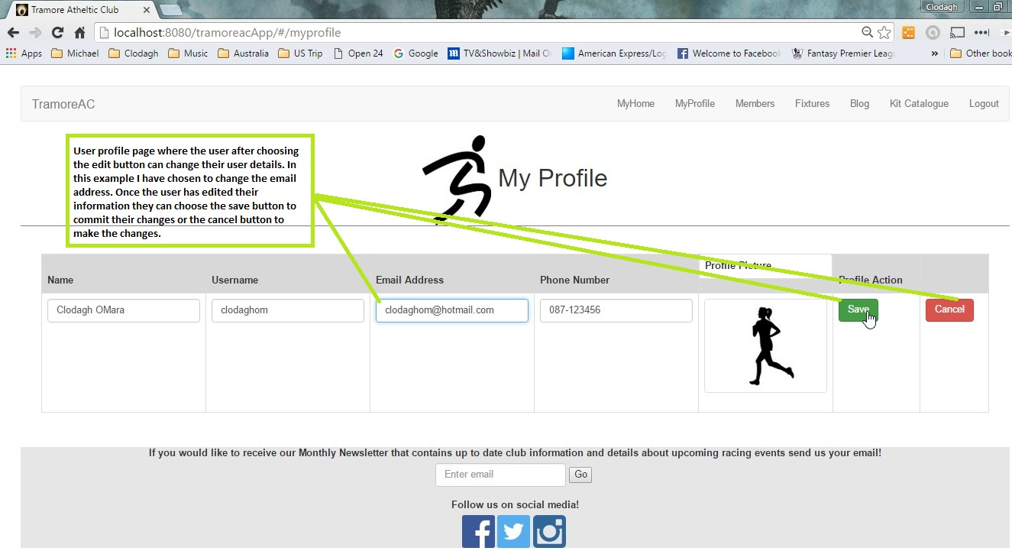

Members View

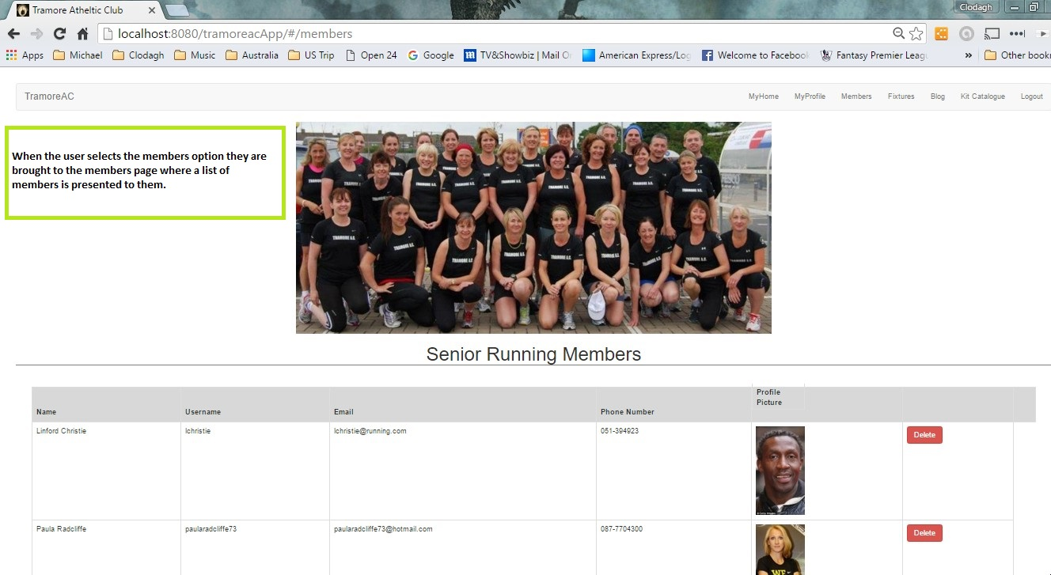

## Member Delete

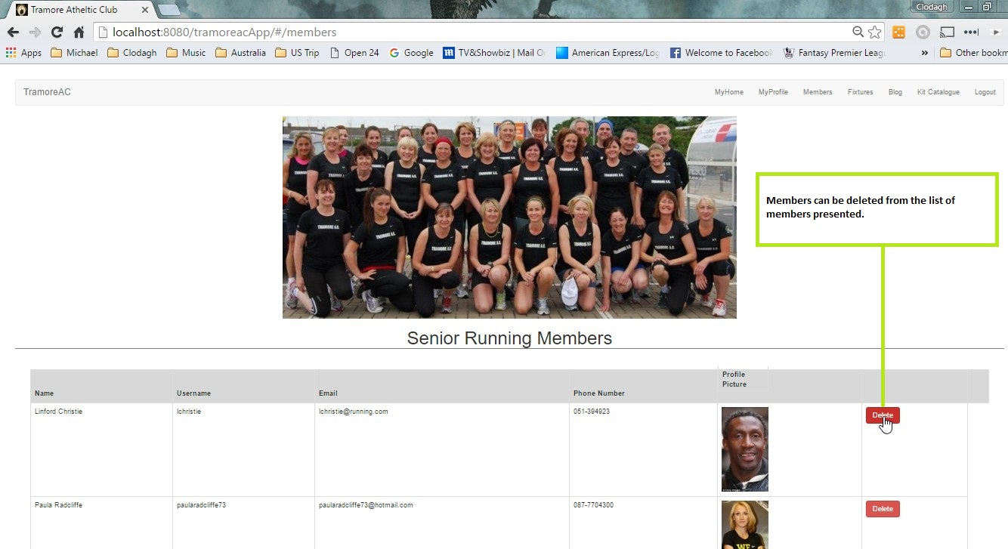

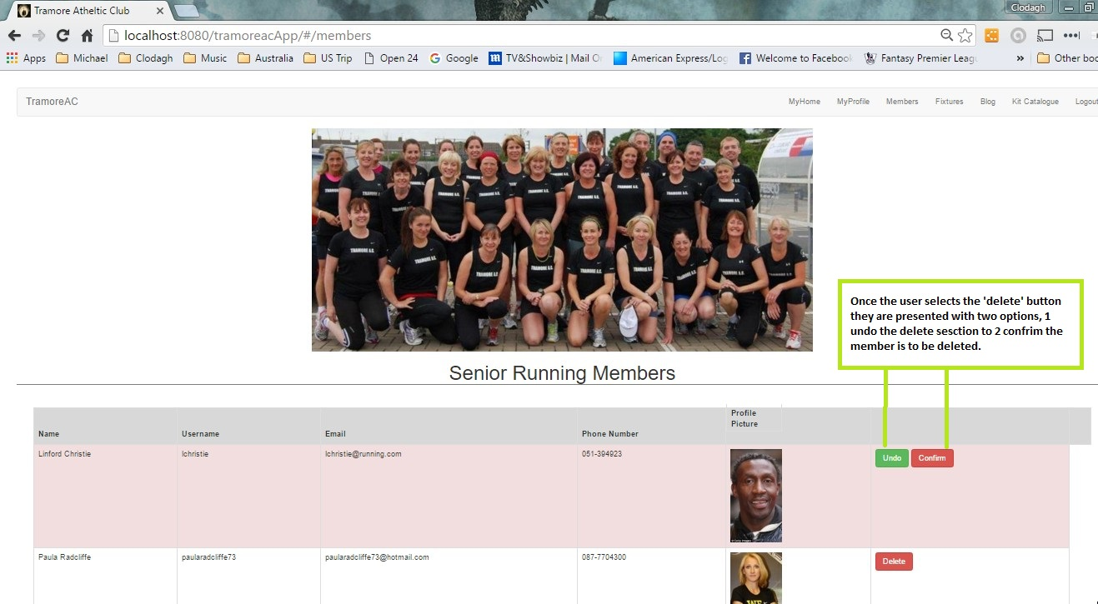

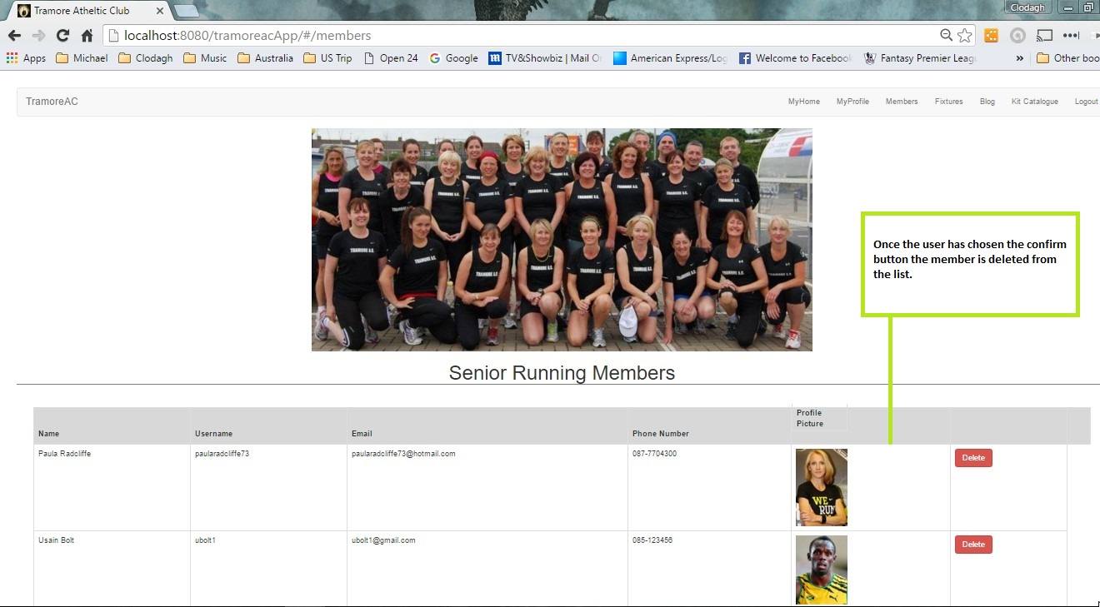

# Fixtures Page

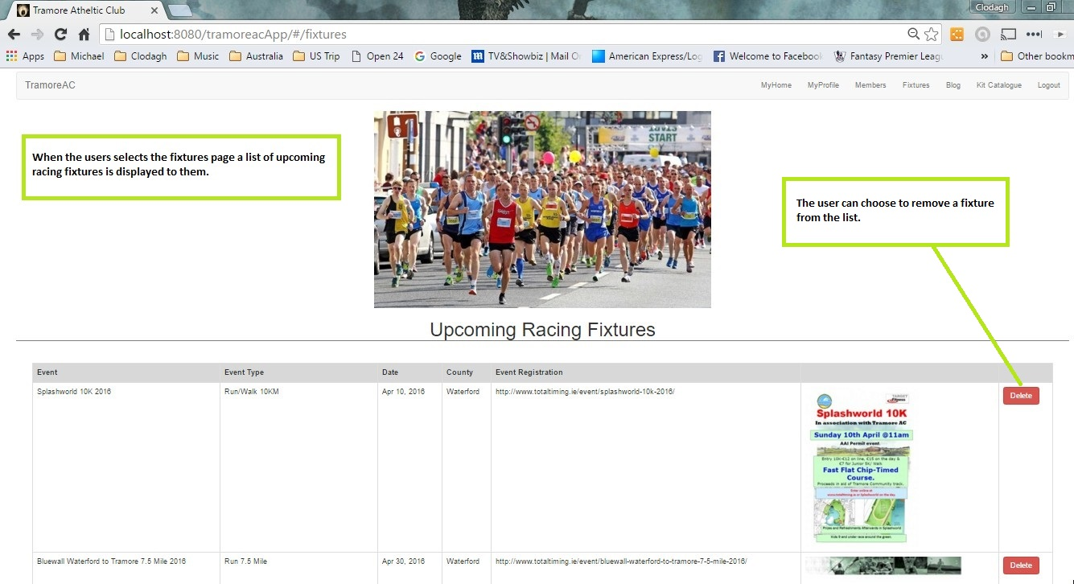

# Blog View

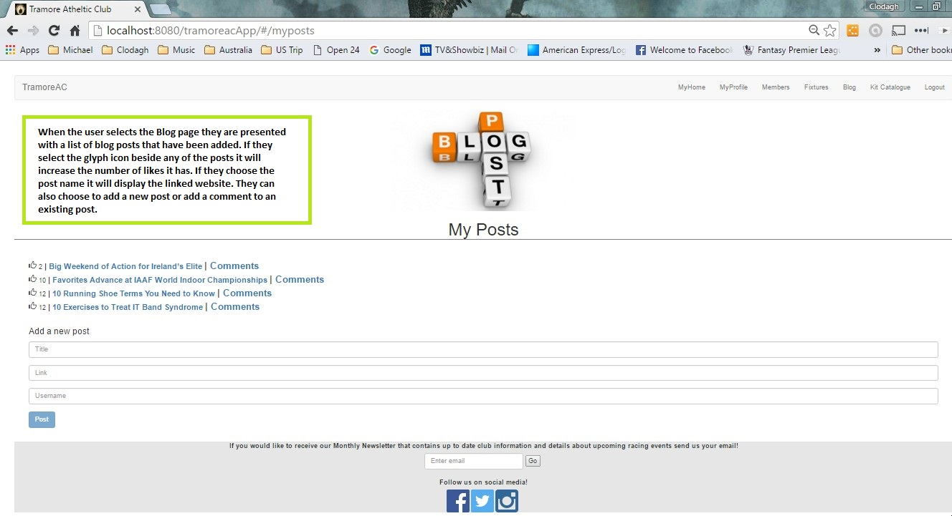

## Add Blog Post

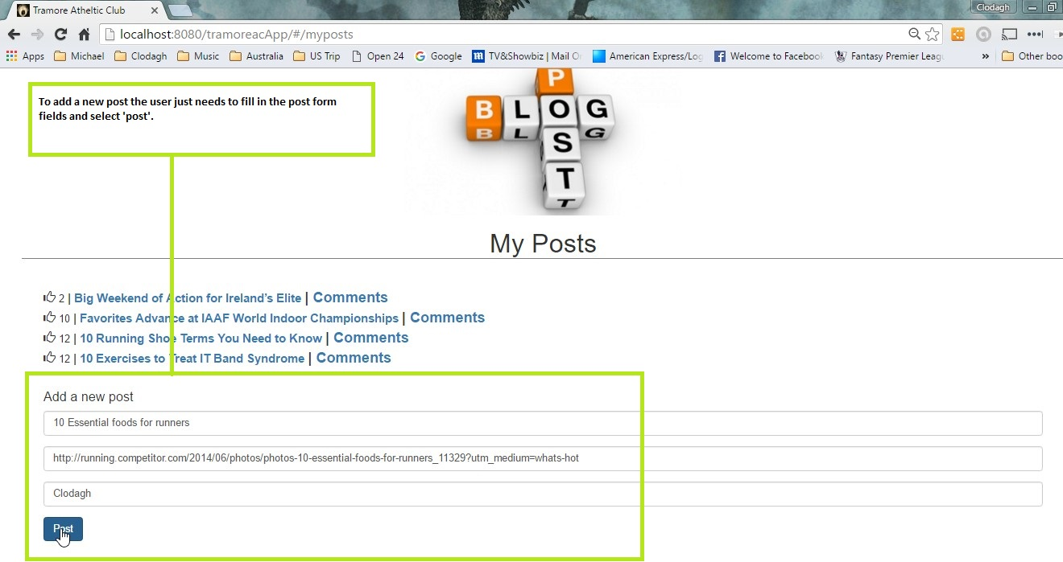

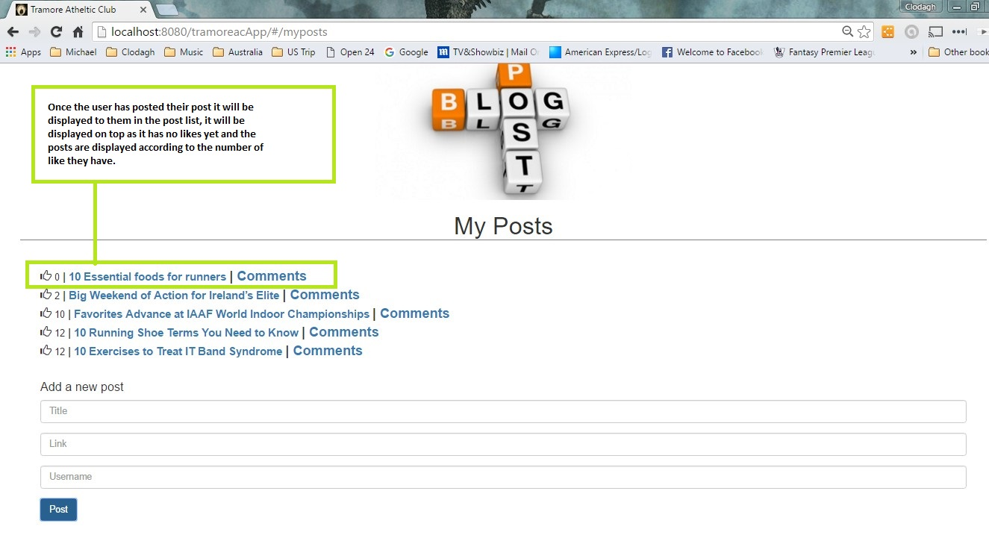

## Post Comment

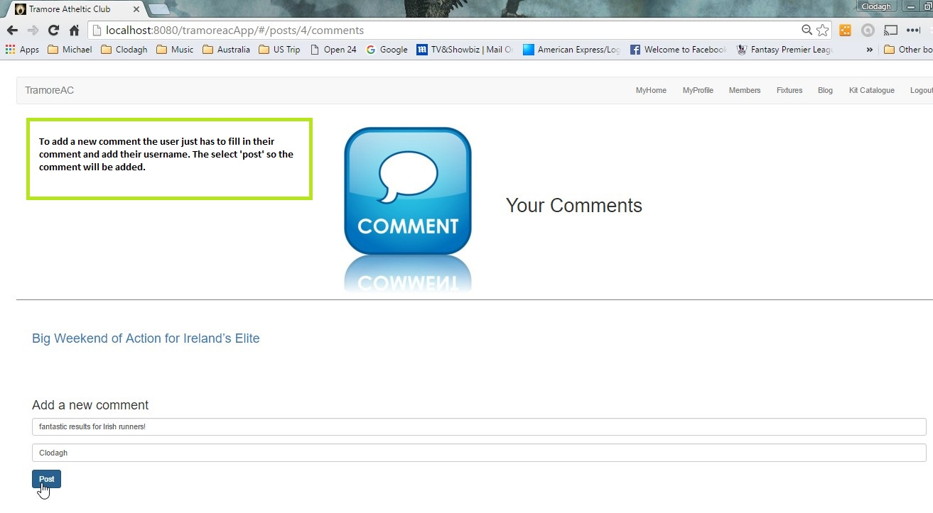

Add Blog Post Comment



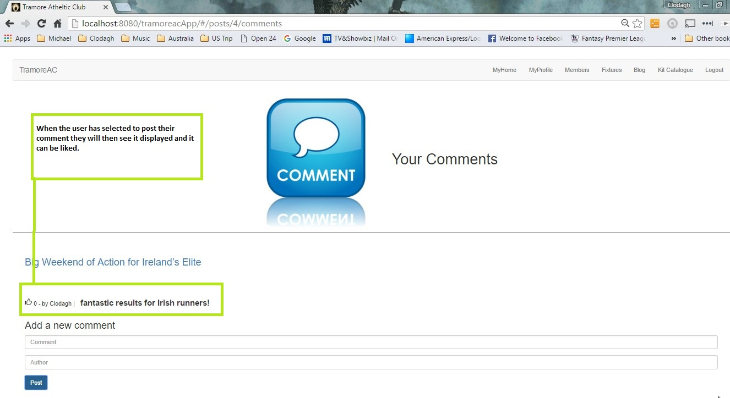

# Kit Catalogue View

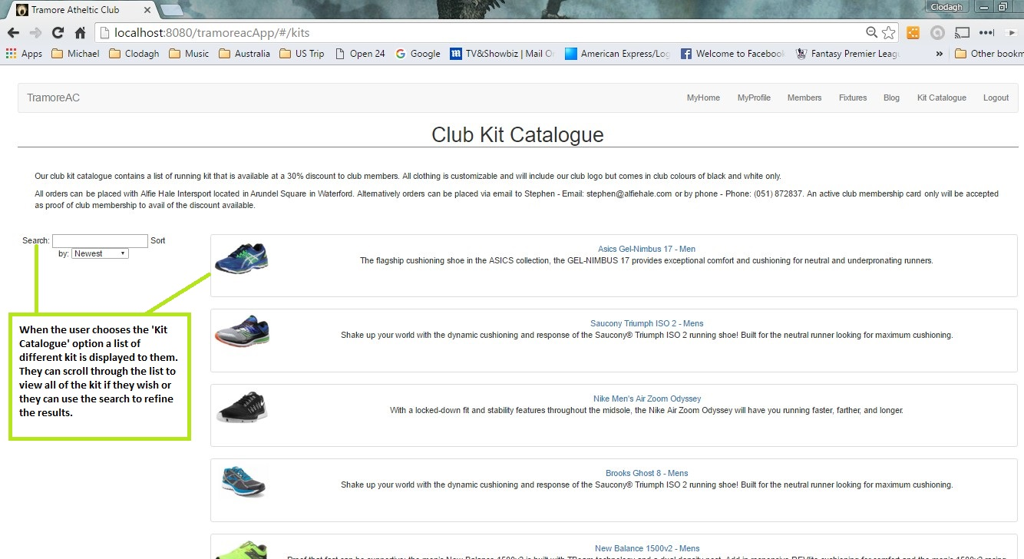

## Kit Catalogue Filtered Views

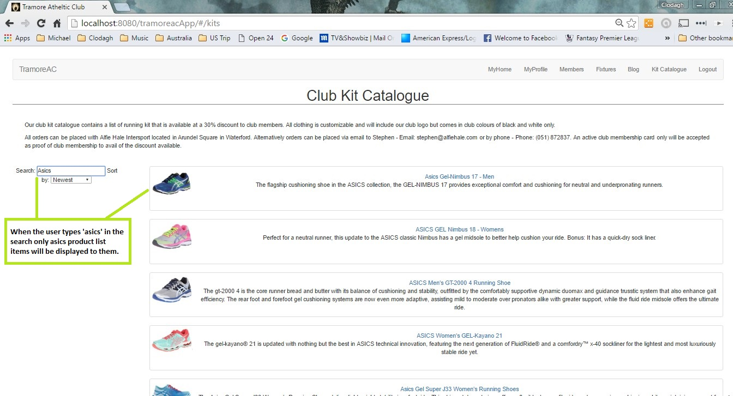

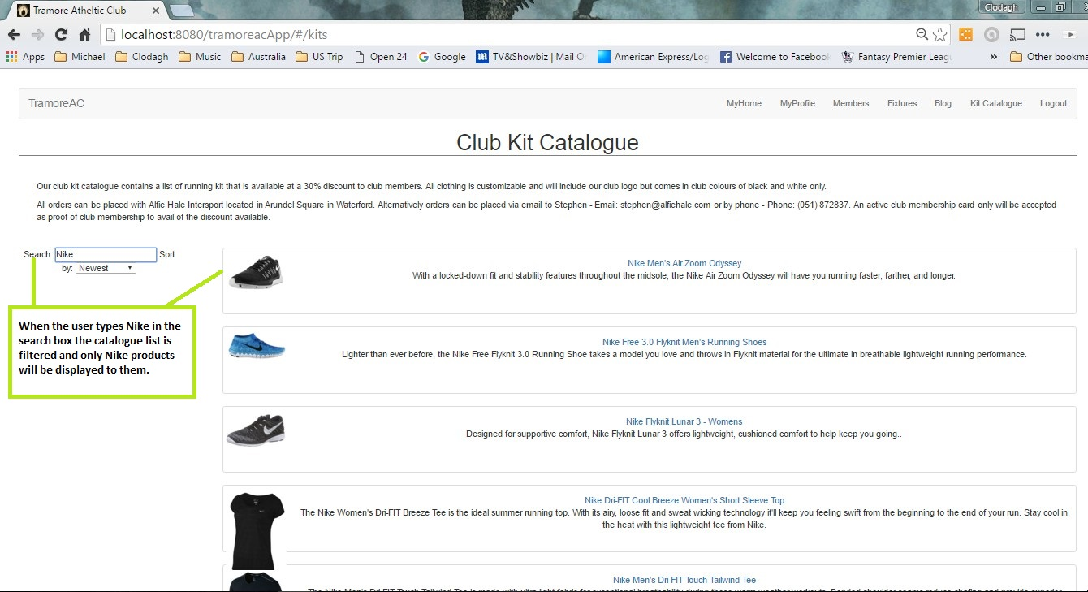

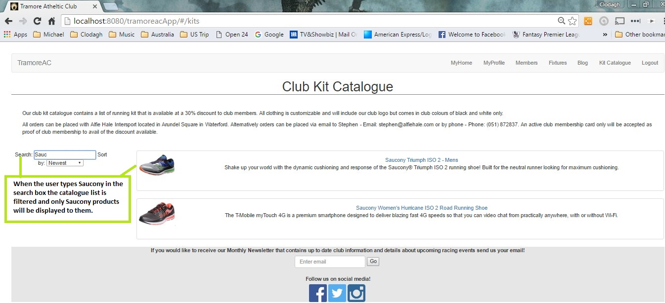

## Kit List Catalogue Item View

